**Lembar Jawaban Search & Sorting**

Nama : Muhammagd Iffan Ramadhan

NIM : 2117020036

Kelas : II.SI.A

**Jawab:**

1. Pseudocode searching

fungsi missData (arr1, arr2, n1, n2)

int i, j

i = 0;

j = 0;

while i < n1 and j < n2 do

if arr[i] < arr2[j] then

print (arr1[i],”,”)

i++

j++

endif

else if arr2[j] < arr[i] then

print (arr2[j],”,”)

i++

j++

endif

else

i++

j++

while i < n1 do

print(arr1[i],”,”)

i++

while j < n2 do

print(arr2[j],”,”)

j++

endfungsi

begin

print(“mencari data yang hilang”)

int arr1[] = {3,5,6,7,8,10}

int arr2[] = {5,6,7,8}

int len1 = size(arr1)

int len2 = size(arr2)

print(arr1)

print(arr2)

missData(arr1, arr2, len1, len2)

end

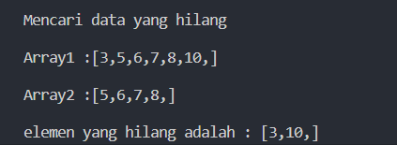

1. Pseudocode sorting
   1. Bubble sort

begin

print(“bubble sorting”)

int arr_b = {100, 99, 98,…, 2, 1}

int len = size(arr_b)

print(arr_b)

start clock

for(int i=0,i<len-1,i++) do

boolean swaps = false

for(int id,id<len-i-1,++id)do

if arr_b[id] > arr_b[id+1] then

swap arr_b[id] with arr_b[id+1]

endif

swaps = true;

endfor

if !swaps then

break for

endif

endfor

stop clock

print(arr_b)

int duration = count duration(stop-start)

print (duration)

end

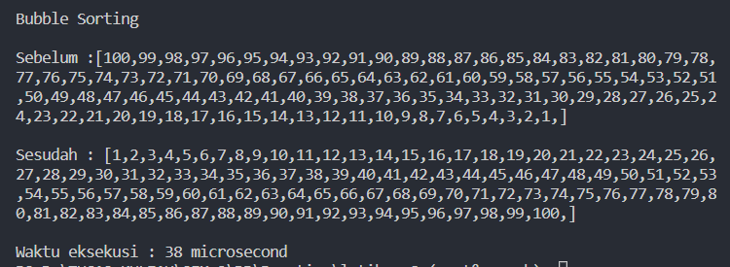

* 1. Selection sort

begin

print(“Selection sorting”)

int arr_s = {100, 99, 98,…, 2, 1}

int len = size(arr_s)

print(arr_s)

start clock

for(int i=0,i<len,++i) do

int lo = i

for(int id=i+1,id<len,++id)do

if arr_s[lo] > arr_s[id] then

lo = id

endif

endfor

swap arr_s[lo] with arr_s[i]

endfor

stop clock

print(arr_s)

int duration = count duration(stop-start)

print (duration)

end

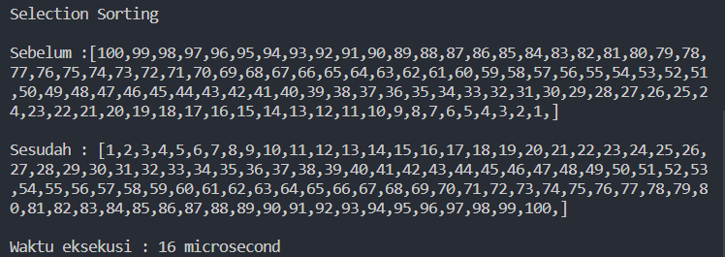

* 1. Insertion sort

begin

print(“insertion sorting”)

int arr_i = {100, 99, 98,…, 2, 1}

int len = size(arr_i)

print(arr_i)

start clock

for(int i=0,i<len,i++) do

for(int b=i+1, b!=0, --b)do

if arr_i[b] > arr_i[b-1] then

swap arr_i[b] with arr_i[b-1]

endif

else do

break for

endfor

endfor

stop clock

print(arr_i)

int duration = count duration(stop-start)

print (duration)

end

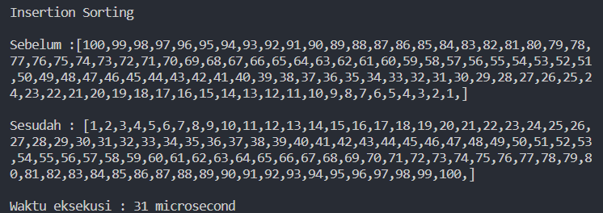

1. Perbandingan waktu eksekusi :
   1. Bubble sort : 38 microdetik
   2. Selection sort : 16 microdetik
   3. Insertion sort : 31 microdetik